Aliaksei B.
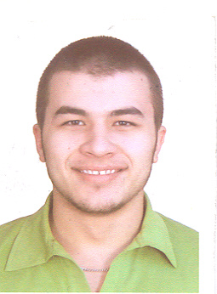
Home address: Vitebsk, Belarus
Home phone: +375210000000
Mobile phone: +375200000000
Date of birth: April 30, 1987
E-mail: mail@email.com
Gender: male

DATES AVAILABLE FOR EMPLOYMENT:
June 1, 2007 –September 1, 2007

EDUCATION:
- 1994 - 2005 Grammar school № 3, Vitebsk.
- 1995 – 2005 School of arts, musical branch, Vitebsk.
- 2005 – present time Vitebsk State Technological University, Vitebsk.
Faculty: Mechanical, 2rd year study.

WORK EXPERIENCE:
July 2006 – August 2006 – The building company “Jhilstroy”, Vitebsk, The worker at height, loader.

June 2006 – Service of a meeting and sending of the international festival of arts “Slavjanskiy Bazar v Vitebske”. A meeting of visitors of city (stars of a foreign show business).Vitebsk.

September 2005 – May 2006 - The assistant to the chief of a student's staff of labor affairs of university, VSTU, Vitebsk.

September 2006 – present time - Vitebsk State Technological University. Participation in scientific work of faculty "Theoretical Mechanics and the Theory of Mechanisms and Machines".

November 2006 - present time - The representative of the company “Territorija Razvle4eniy” (Minsk) in Vitebsk, PR-manager of corporate parties.

INTEREST: music, dances, cars, computer technique, public work, scientific activity at university.

ADDITIONAL SKILLS:
- IT: user of PC
- Intermediate English
- Driving license
- Great communicative skills
JOB PREFERENCES:
Moving.

