R E S U M E

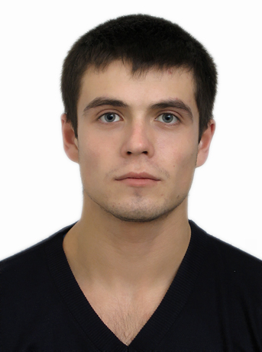 | Full Name | Vladimir H
 | Address | Ukraine
 | Date of Birth  (mm/dd/yyyy) | 09/14/1983
 | E-mail | mail@mail.ru
 | Phone # | +3733333333
 | Arrival Date  (mm/dd/yyyy) | 05/15/2007
 | Leaving Date  (mm/dd/yyyy) | 09/15/2007
 | English Level | Intermediate

Past Work Experience

Since 2003 trainer –instructor in gym, Chisinau
2003-2002 trainer of swimming, Sport Complex, Chisinau

Professional Qualifications:

1999 Master Sport Diploma, I place – swimming , III place – swimming Sankt Petersburg, I place – painting
2000 III place submarine shooting, Ukraine, Nikolayev

Education

2006-2003 State University of Cahul
2001-1991 Sport College

Skills / Language

Other Languages | Russian- advanced, Romanian – advanced , Ukrainian-advanced
Computer Skills | Word ,Excel, Power Point, Programming, Internet
Do you have an international driver's license? | No
Do you have a driver's license in your home country? | Yes, category B, C
Have you ever worked in the US? | No
Have you ever visited the US? | No
Hobbies | Sports, swimming, drive cars, computer, gym

Why I would make a good employee for work & travel job...

I would like work and at the same time want to find out better this wonderful country, to know a lot of new interesting people and to learn better the English language. I have worked, as you can see from my work history in a gym and I am a trainer of swimming, I have participated to several international competitions and I have gained a lot of awards. I am in very good physical form, I can adapt to several work conditions, I am very organized and reliable. I like to learn new things and I think that this experience will help me in future.
I like to socialize with people, I am polite and trustworthy.

