R E S U M E

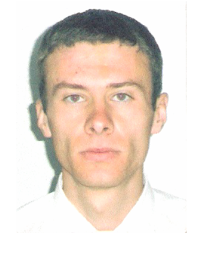 | Full Name | Andrey Andreev
 | Address | Republic of Moldova
 | Date of Birth  (mm/dd/yyyy) | 06. 08 1984
 | E-mail
 | Phone # | 373 7777777777
 | Arrival Date  (mm/dd/yyyy) | 05/15/2007
 | Leaving Date  (mm/dd/yyyy) | 09/15/2007
 | English Level | Intermediate

Past Work Experience

2002-present Metro Cash& Carry, merchandiser and stocker
Chisinau, Moldova
1999-2001 Coca Cola, mover, Chisinau, Moldova

Education

Technical University of Moldova Major: Engineering and Transport Management

Skills / Language

Other Languages | English(conversational),Russian(advanced),French (conversational
Computer Skills | PC operator
Do you have an international driver's license? | No
Do you have a driver's license in your home country? | Yes, driving license A
Have you ever worked in the US? | No
Have you ever visited the US? | No
Hobbies | Traveling, cooking, making music, computer arts, entertaining friends

Why I would make a good employee for work & travel job...

I am a creative person, always full of new ideas to be implemented in my work. I have a special ability to solve conflicts trying to overcome any stressful situation that may appear. I am likable and ambitious and I am also a serious and enthusiastic student. I have some experience in the job I am going to perform in the Sates, I am in good health and strong enough to meet all the work requirements. I am looking forward to starting my job as soon as possible.

