R E S U M E

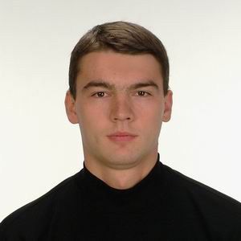 | Full Name | Pavel Pavlov
 | Address | Republic of Moldova
 | Date of Birth  (mm/dd/yyyy) | 03/22/1980
 | E-mail | Mail@Email.com
 | Phone # | +33333333333
 | Arrival Date  (mm/dd/yyyy) | 05/15/2007
 | Leaving Date  (mm/dd/yyyy) | 09/15/2007
 | English Level | advanced

Past Work Experience

2001-2004, TRIADA Holding, Chisinau, Moldova – Position - Bodyguard
2004-2006, Taekwon-Do Association, Chisinau, Moldova - Position: Coach

Education

1995-1998, Biochemical College, Chisinau, Moldova - Bachelor Degree
1998-2004, State Medical University, Chisinau, Moldova - MD Degree
2005- present, State Real Sciences University, Cahul, Moldova - 2nd year student

Skills / Language

Other Languages | -German - conversational  -Romanian - advanced  -Russian - advanced
Computer Skills | Advanced in Microsoft, Adobe, Corel, Autodesk products.
Do you have an international driver's license? | No.
Do you have a driver's license in your home country? | Yes.
Have you ever worked in the US? | No.
Have you ever visited the US? | No.
Hobbies | Martial Arts, Yoga, physical fitness – gym.

Why I would make a good employee for work & travel job...

I am intelligent, serious and hard working. I possess a sociable, self-reliant and independent personality. During all these years, I learnt to work in a team, to have a creative climate and a cooperative exchange of ideas. I am reliable and committed to my job. I like to learn new things, and I’m not afraid to do physical work. I also speak German, Russian and Romanian and I like working in a various cultural environment.

