Sample Resume of a Candidate for Seasonal Employment in Hospitality Industry. (Housekeeping)
PERSONAL INFORMATION
First, last name: | Ksenia C. | Country: | Russia | Native language: | Russian

Gender: |  | Date of birth. Month: |  | Day: | 27 | Year:

Home mailing address: | Ufa, Russia

Home phone number:  (country code - city code - number) | 777777777777 | Mobile phone number:  (country code - network code - number) | 77777777777

E-mail: | tigrena27@yahoo.com | How often you check e-mail:

Height (ft, in): | 5.8 | Weight (lbs): | 133

Size of t-shirt: |  | Size of trousers:
EDUCATION, WORK EXPERIENCE, SKILLS
Educational Institution: | Ufa State Aviation University

Field of study: | Applied Information Science in Economics | How many years will you complete next summer:

Date you plan to arrive to USA: | 05.06.2007 | Latest date you can return: | 15.10.2007

Computer experience: |  | Driving experience:

Swimming ability |  | Do you smoke?

Your interests/hobbies/skills:  (cooking, cleaning, gardening, playing piano, carpentry, sports, animals, etc – be detailed) | snowboarding, bicycle riding, cooking, reading classical books boo, listening to music, aerobics.

What other commonly used languages do you know: | Russian, English

Part-time work as a shop assistant for 1 year in a mobile selling shop, full-time shop assistant in a souvenir shop (3 months),waitress in a café (3 months), supermarket merchandiser (2 months), regional representative of marketing company (september 2006-now).
Do housekeeping, gardening, baby-sitting at home.
I'd like to work in the US because I want to earn money to be independent from parents, because I want to meet new people and make new friends, to expand my outlook.
To my mind an ideal summer job is doing interesting work together with friendly co-workers for a reasonable salary.
I'm good-looking, communicative, sociable, reliable, initiative, pesponsible, punctual and I'm a quick learner.
I have broad experience with cash register, computer, R-keeper, Internet. I get along with people very well. As I have four nephews and a niece I'm fairly good at baby-sitting.

PHOTOS
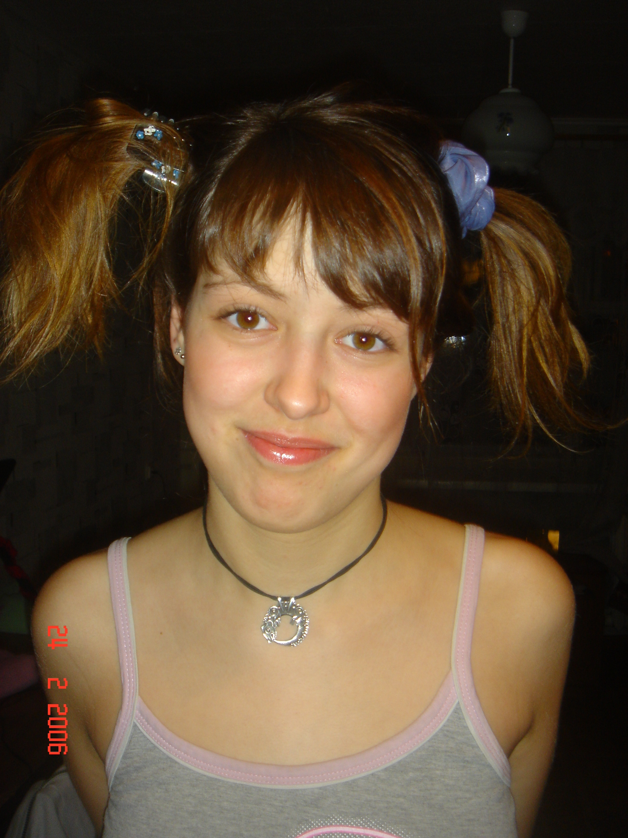
 PASTE YOUR FULL- LENGTH PHOTO HERE

