Sample Resume of a Candidate for Seasonal Employment in Hospitality Industry. (Housekeeping.)

PERSONAL INFORMATION
First, last name: | Maria, L | Country: | Russia | Native language: | Russian

Gender: |  | Date of birth. Month: |  | Day: | 19 | Year:

Home mailing address: | Russia

Home phone number:  (country code - city code - number) | 7777777777 | Mobile Phone | 777777777

E-mail: | Yahoo@yahoo.com | How often you check e-mail:

Height (ft, in): | 5, 6 | Weight (lbs): | 113

Size of t-shirt: |  | Size of trousers:
EDUCATION, WORK EXPERIENCE, SKILLS
Educational Institution: | Tambov State Technical University

Field of study: | Economics and management | How many years will you complete next summer:

Date you plan to arrive to USA: | 21.05.07 | Latest date you can return: | 30.08.07

Computer experience: |  | Driving experience:

Swimming ability |  | Do you smoke?

Your interests/hobbies/skills:  (cooking, cleaning, gardening, playing piano, carpentry, sports, animals, etc – be detailed) | Fitness, skating, animals, computer, dancing, cleaning

Speak English: |  | Written English: |  | Listen English:

What other commonly used languages do you know: | Russian

Indicate following information about each employer or work experience you have:  Name of the company, period (mm/yyyy-mm/yyyy):  Your position and responsibilities:  Please give a detailed review of your previous working history. It is very important to know what duties you can take up. List every experience you have (no matter – paid, volunteer or work done at home). | Open company "Whirlwind", 06/2005: seller-adviser (I sold a very good range of cosmetics and helped clients to choose from it);  Open company "Ecoproduct", 07/2005-08/2005: secretary (I worked on a computer, made schedules of sales of the products and answered the telephone);  Café "Pizza Land", 06/2006-08/2006: waitress (I took orders, served clients and recommended them dishes).
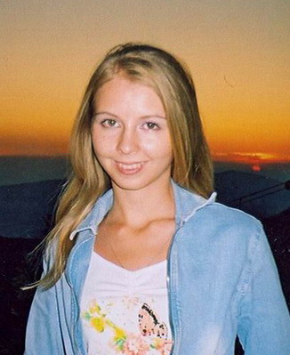

PLEASE PASTE YOUR PORTRAIT SMILING PHOTO HERE

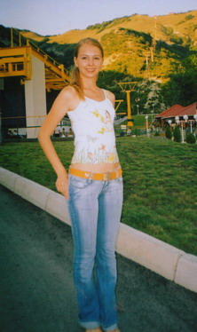
PLEASE PASTE YOUR FULL- LENGTH PHOTO HERE

