Sample Resume of a Candidate for Seasonal Employment in Hospitality Industry. (Housekeeping)

PERSONAL INFORMATION
First, last name: | Albina A. | Country: | Russia | Native language: | Russian

Gender: |  | Date of birth. Month: |  | Day: | 11 | Year:

Home mailing address: | Russian Federation

Home phone number:  (country code - city code - number) | 77777777 | Mobile phone number:  (country code - network code - number) | 7777777777777

E-mail: | yahoo@yahoo.com | How often you check e-mail:

Height (ft, in): | 5.47 | Weight (lbs): | 111

Size of t-shirt: |  | Size of trousers:
EDUCATION, WORK EXPERIENCE, SKILLS
Educational Institution: | Bashkir State Pedagogical University

Field of study: | English | How many years will you complete next summer:

Date you plan to arrive to USA: | 05.06.2007 | Latest date you can return: | 15.10.2007

Computer experience: |  | Driving experience:

Swimming ability |  | Do you smoke?

Your interests/hobbies/skills:  (cooking, cleaning, gardening, playing piano, carpentry, sports, animals, etc – be detailed) | sports (basketball), listening to music, collecting unusual  photos

Have you previously been to the United States? If “yes”, indicate [x] from the right:

I have had work as a coach in a camp in summer (2 months), interviewer in a sociological agency (3 months), private tuition in English to school children (1 year), promoter for beer producing company "Sokol" (2 months).
I have experience is working with people, comminicating to children, promoting goods. Besides I can do everything aabout housekeeping and garnening as I help my parents whom live in the rural area.
I would like to work in the United States, so I can have a better idea of the country and its people. I will be a great employee, since I am always very industrious and try to do my work right. I can also work in a team just as well as alone. If needed, I can work overtime hours.
PHOTOS
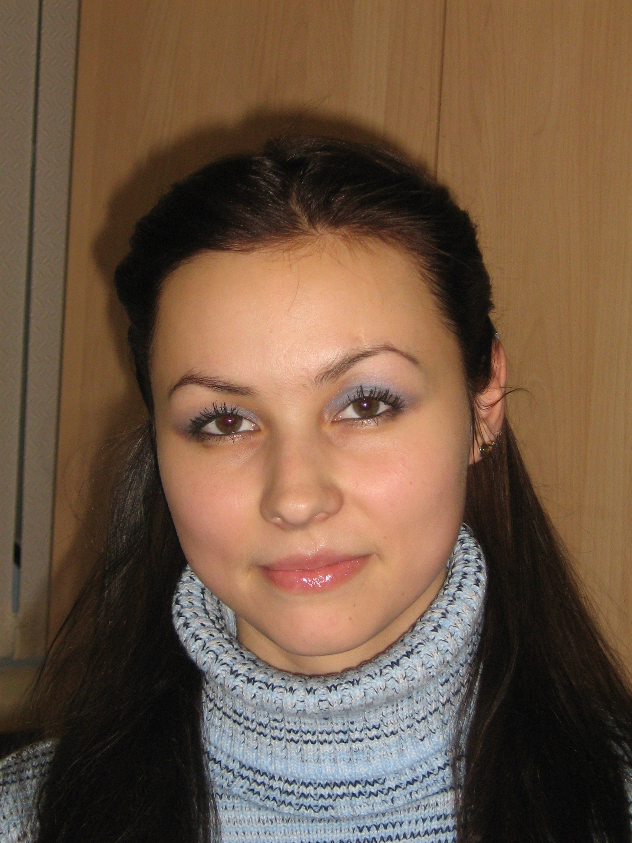TRAIT SMILING PHOTO HERE

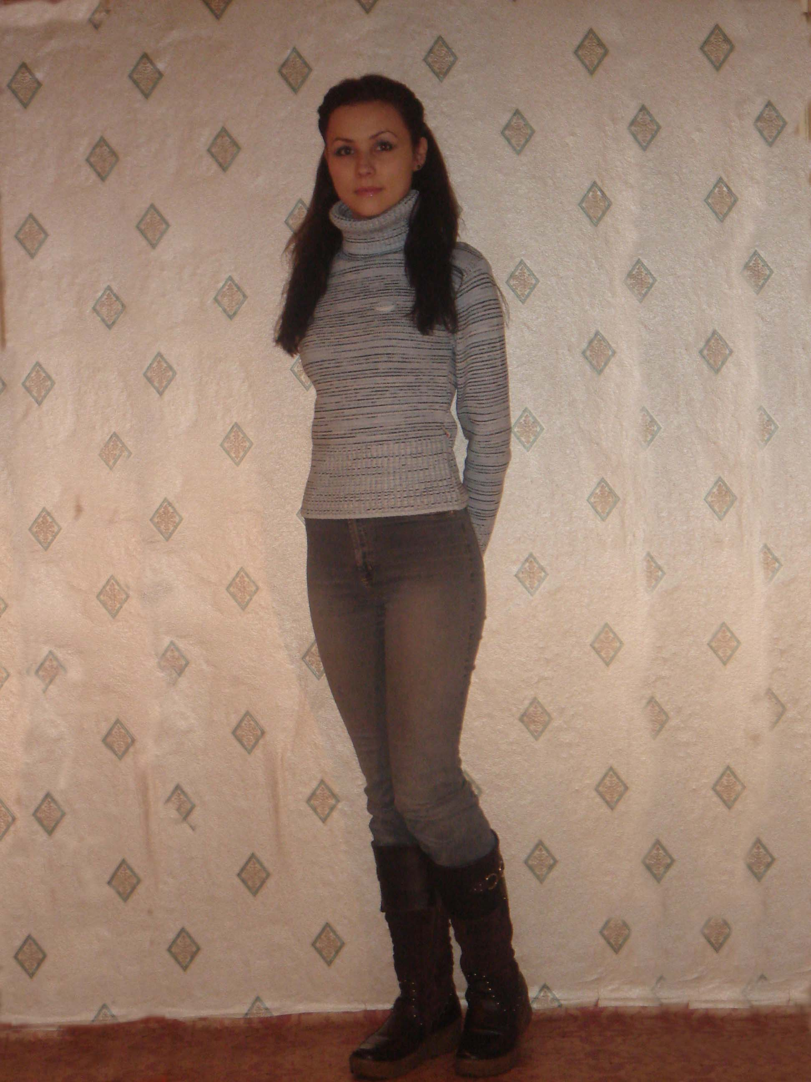
PLEASE PASTE YOUR FULL- LENGTH PHOTO HERE

