Sample Resume of a Candidate for Seasonal Employment in Hospitality Industry. (Housekeeping)
PERSONAL INFORMATION
First, last name: | Aleksandra T | Country: | Russia | Native language: | Russian

Gender: |  | Date of birth. Month: |  | Day: | 11 | Year:

Home mailing address: | Izhevsk, Russia

Home phone number:  (country code - city code - number) | 777777777777 | Mobile phone number:  (country code - network code - number) | 77777777777777

E-mail: | Yahoo@yahoo1.com | How often you check e-mail:

Height (ft, in): | 5'7'' | Weight (lbs): | 117

Size of t-shirt: |  | Size of trousers:
EDUCATION, WORK EXPERIENCE, SKILLS
Educational Institution: | Izhevsk State Technical University

Field of study: | Management and Marketing | How many years will you complete next summer:

Date you plan to arrive to USA: | 27, May, 2007 | Latest date you can return: | 01, Oct, 2007

Computer experience: |  | Driving experience:

Swimming ability |  | Do you smoke?

Your interests/hobbies/skills:  (cooking, cleaning, gardening, playing piano, carpentry, sports, animals, etc – be detailed) | Dancing, computers, music, cinema, animals, cooking,  sports, camping trips, psychology

Speak English: |  | Written English: |  | Listen English:

What other commonly used languages do you know: | German - beginner

Family Restaurant "Cheshirsky kot" (summer of 2005 and summer of 2006), waitress. My responsibility was to serve customers.
Editor's office "News of Udmurt Republic", (September/2006 - till now), advertising manager. My responsibility is finding advertisers.

I can drive a car, communicate with a lots of different people. I'm good at dancing and computer science.
I would like to work in the USA, first of all, because I want to see the famous sights of America. They say that it is very beautiful country. America is a great country and I really want to see it by myself. Also I would like to improve my English. Besides I want to get life experience, new impressions and to learn how to cope with difficulties. Finally I want to meet some new people and find new friends from different countries. An ideal summer job for me is a job with people and job with computers. I have conceptual, decision making, communicational and interpersonal skills. I'm a hardworking, polite, accurate, honest and decent person. I'm cheerful and like to smile. I have pleasant appearance, resistance to stress. Also I'm compulsory and responsible person. I'll try to be of maximum use.
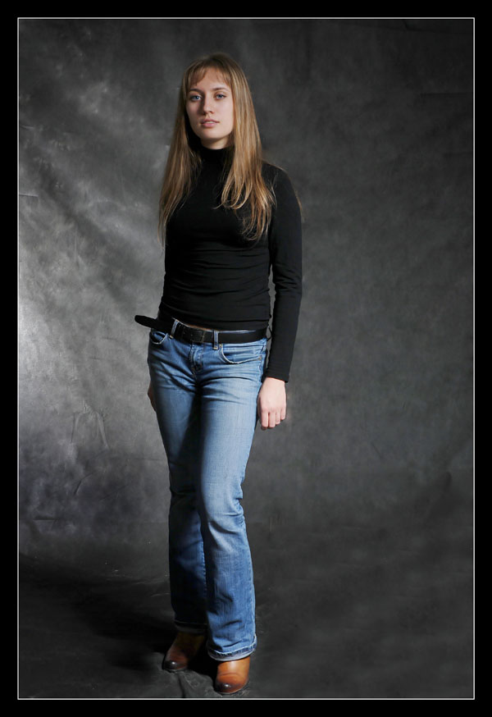
PLEASE PASTE YOUR FULL- LENGTH PHOTO HERE

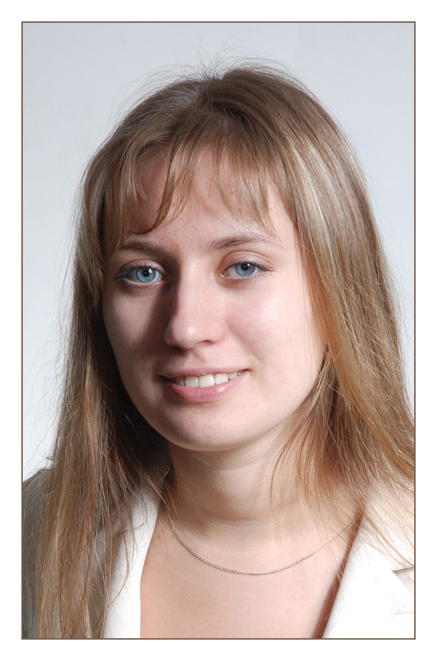

PLEASE PASTE YOUR PORTRAIT SMILING PHOTO HERE

