Resume of a Ride Operator from Russia.

Resume of a foreign candidate for summer employment as a ride operator.
PERSONAL INFORMATION
First, last name: | Zurida G. | Country: | Russia | Native language: | Russian

Gender: | Female | Date of birth. Month: | January | Day: | 01 | Year: | 1987

Home mailing address: | Russia, Karachaevo

Home phone number:  (country code - city code - number) | +7-XXXXXXXXXXX | Mobile phone number:  (country code - network code - number) | +7 XXXXXXXXXXX

E-mail: | Z@mail.ru | How often you check e-mail: | Twice a week

Height (ft, in): | 5’3” | Weight (lbs): | 119

Size of t-shirt: | Small | Size of trousers: | Small
EDUCATION, WORK EXPERIENCE, SKILLS
Educational Institution: | Moscow Open Social University

Field of study: | Linguistics | How many years will you complete next summer: | 4

Date you plan to arrive to USA: | May,26 2008 | Latest date you can return: | October, 1 2008

Computer experience: | Average User | Driving experience: | No

Swimming ability | Average level | Do you smoke? | No

Your interests/hobbies/skills:  (cooking, cleaning, gardening, playing piano, carpentry, sports, animals, etc – be detailed) | Listening to music, reading books, watching TV.

What other commonly used languages do you know: | German, beginner

Indicate following information about each employer or work experience you have:  Name of the company, period (mm/yyyy-mm/yyyy):  Your position and responsibilities:  Please give a detailed review of your previous working history. It is very important to know what duties you can take up. List every experience you have (no matter – paid, volunteer or work done at home). | I work at my parents’shop every summer with my sister. I perform the duties of a cashier,I consult customers,I clean shelves.At home I cook,wash the dishes,clean the house.
PLACEMENT
Will you be able to transfer a housing deposit?  (housing deposits are returned in case you are refused a visa in US Embassy) | No

List jobs which you are not willing to do: | Housekeeper

Communicating wish: | Lots of people. | Co-workers preference: | Native speakers
GENERAL RESTRICTIONS

Do you have any allergies or health problems that may affect your ability to work? If “yes”, indicate [x] from the right:

If “yes”, please explain: | I can’t stand the heat and dust.

INTERVIEW
Imagine that you have to prove your suitability for a job. Employer looks through 10 candidates. Why choose you?
Tips for successful story:  Why would you like to work in U.S.?  What is your idea of ideal summer job?  What personal qualities and skills can you offer to an Employer?  Describe yourself (character, personal abilities, merits and demerits, habits) | I’d like to work in the U.S. because I want to improve my English through communicating with native speakers, to travel, to get to know the country. Ideal summer job for me is working with interesting people in a well-paid job. I am a hard-working, communicative, responsible person. I am marry, friendly, I am always in a good mood.
EXPECTATIONS
Rate following aspects of your place of work/residence in U.S.:
Entertainments accessibility (city life advantages: restaurants, discotheques, shops, bars, night clubs, etc.) | It doesn’t matter.

Enrichment chance (easy to find the second job and to have overtime) | It is important.

Nature closeness (rural area with frank people, clean air, outdoor activities and quiet life) | It is not quite important.

If there are any other request to your future place of work, write here:  If you are looking for specific position or location, or if it is obligatory to be placed with a friend, etc.  Be noticed that more requests you have means less chances for your placement. Keep it simple. | I would prefer to work with my sister.
LOCATION
Choose where you would like to go:
Northeast - New York, Connecticut, Maine, Massachusetts, New Jersey, New Hampshire, Pennsylvania, Ohio, Rhode Island, Vermont, Maryland, Delaware | New Jersey-I prefer there.

PHOTOS
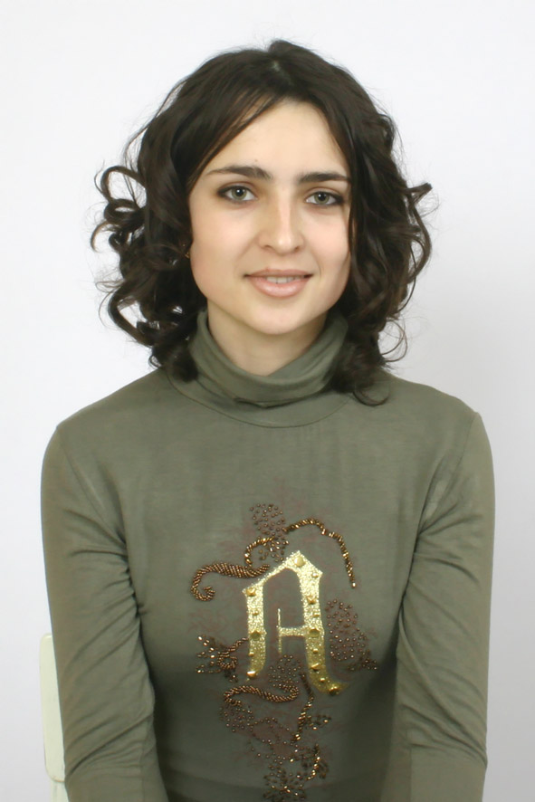

PLEASE PASTE YOUR PORTRAIT SMILING PHOTO HERE

