Sample Resume Of An International Student Worker From Russia.
PERSONAL INFORMATION
First, last name: | Evgeniy. S | Country: | Russia | Native language: | Russian

Gender: | Male | Date of birth. Month: | August | Day: | 15 | Year: | 1987

Home mailing address: | 77 J1 Street, City, Russia

Home phone number:  (country code - city code - number) | +7-500-550-55555 | Mobile phone number:  (country code - network code - number) | +7-910-55555555

E-mail: | Internationalstudent.com | How often you check e-mail: | Every day

Height (ft, in): | 6’ | Weight (lbs): | 183

Size of t-shirt: | L | Size of trousers: | 14
EDUCATION, WORK EXPERIENCE, SKILLS
Educational Institution: | Kursk State Technical University

Field of study: | Construction | How many years will you complete next summer: | 3

Date you plan to arrive to USA: | June, 1st | Latest date you can return: | September, 15th

Computer experience: | Average User | Driving experience: | Average

Swimming ability | Average | Do you smoke? | No

Your interests/hobbies/skills:  (cooking, cleaning, gardening, playing piano, carpentry, sports, animals, etc – be detailed) | Playing guitar, tennis, collecting

Speak English: | Average | Written English: | Average | Listen English: | Average

What other commonly used languages do you know:

Indicate following information about each employer or work experience you have:  Name of the company, period (mm/yyyy-mm/yyyy):  Your position and responsibilities:  Please give a detailed review of your previous working history. It is very important to know what duties you can take up. List every experience you have (no matter – paid, volunteer or work done at home). | “Kurskgazstroy” (Russia, Kursk)  06/2005-08/2005, 06/2006-08/2006  I worked as a mechanic. I was responsible for helping the welder.  I'm also experienced in planting trees and cleaning the house.
PLACEMENT
Will you be able to transfer a housing deposit?  (housing deposits are returned in case you are refused a visa in US Embassy) | Yes

List jobs which you are not willing to do:

Communicating wish: | Collective only | Co-workers preference: | Russians
GENERAL RESTRICTIONS
Do you have visible tattoos, body piercing, informal appearance? If “yes”, indicate [x] from the right:

If “yes”, please explain: | Small ring in the left ear

Do you have any allergies or health problems that may affect your ability to work? If “yes”, indicate [x] from the right:

If “yes”, please explain:

INTERVIEW
Imagine that you have to prove your suitability for a job. Employer looks through 10 candidates. Why choose you?
Tips for successful story:  Why would you like to work in U.S.?  What is your idea of ideal summer job?  What personal qualities and skills can you offer to an Employer?  Describe yourself (character, personal abilities, merits and demerits, habits) | Judging by my previous experience, personal qualities and the level of the language, I can say that I will be an ideal worker for your company. I’m hard working, reliable, responsible and open to new ideas. I always fulfill the duties and can be in charge. I have been working for 2 years and my employers are usually satisfied with my work. I’m mature and independent and I’m eager to work in the States. I hope my working experience abroad will help me later on in life. I’m looking forward to working for your company.
EXPECTATIONS
Rate following aspects of your place of work/residence in U.S.:
Entertainments accessibility (city life advantages: restaurants, discotheques, shops, bars, night clubs, etc.) | Not important

Enrichment chance (easy to find the second job and to have overtime) | Important

Nature closeness (rural area with frank people, clean air, outdoor activities and quiet life) | Not important

If there are any other request to your future place of work, write here:  If you are looking for specific position or location, or if it is obligatory to be placed with a friend, etc.  Be noticed that more requests you have means less chances for your placement. Keep it simple. | I’d like to be placed with Nickolay Ivanov.
LOCATION
Choose where you would like to go:
Northeast - New York, Connecticut, Maine, Massachusetts, New Jersey, New Hampshire, Pennsylvania, Ohio, Rhode Island, Vermont, Maryland, Delaware | It is possible

Midwest - Illinois, Indiana, Iowa, Kansas, Michigan, Minnesota, Missouri, Nebraska, North Dakota, South Dakota, Wisconsin | It is possible

South - Florida, Georgia, North Carolina, South Carolina, Virginia, West Virginia, Alabama, Kentucky, Mississippi, Tennessee, Arkansas, Louisiana, Oklahoma, Texas | It is possible

West - California, Oregon, Washington, Arizona, Colorado, Idaho, Montana, Nevada, New Mexico, Utah, Wyoming | It is possible
PHOTOS
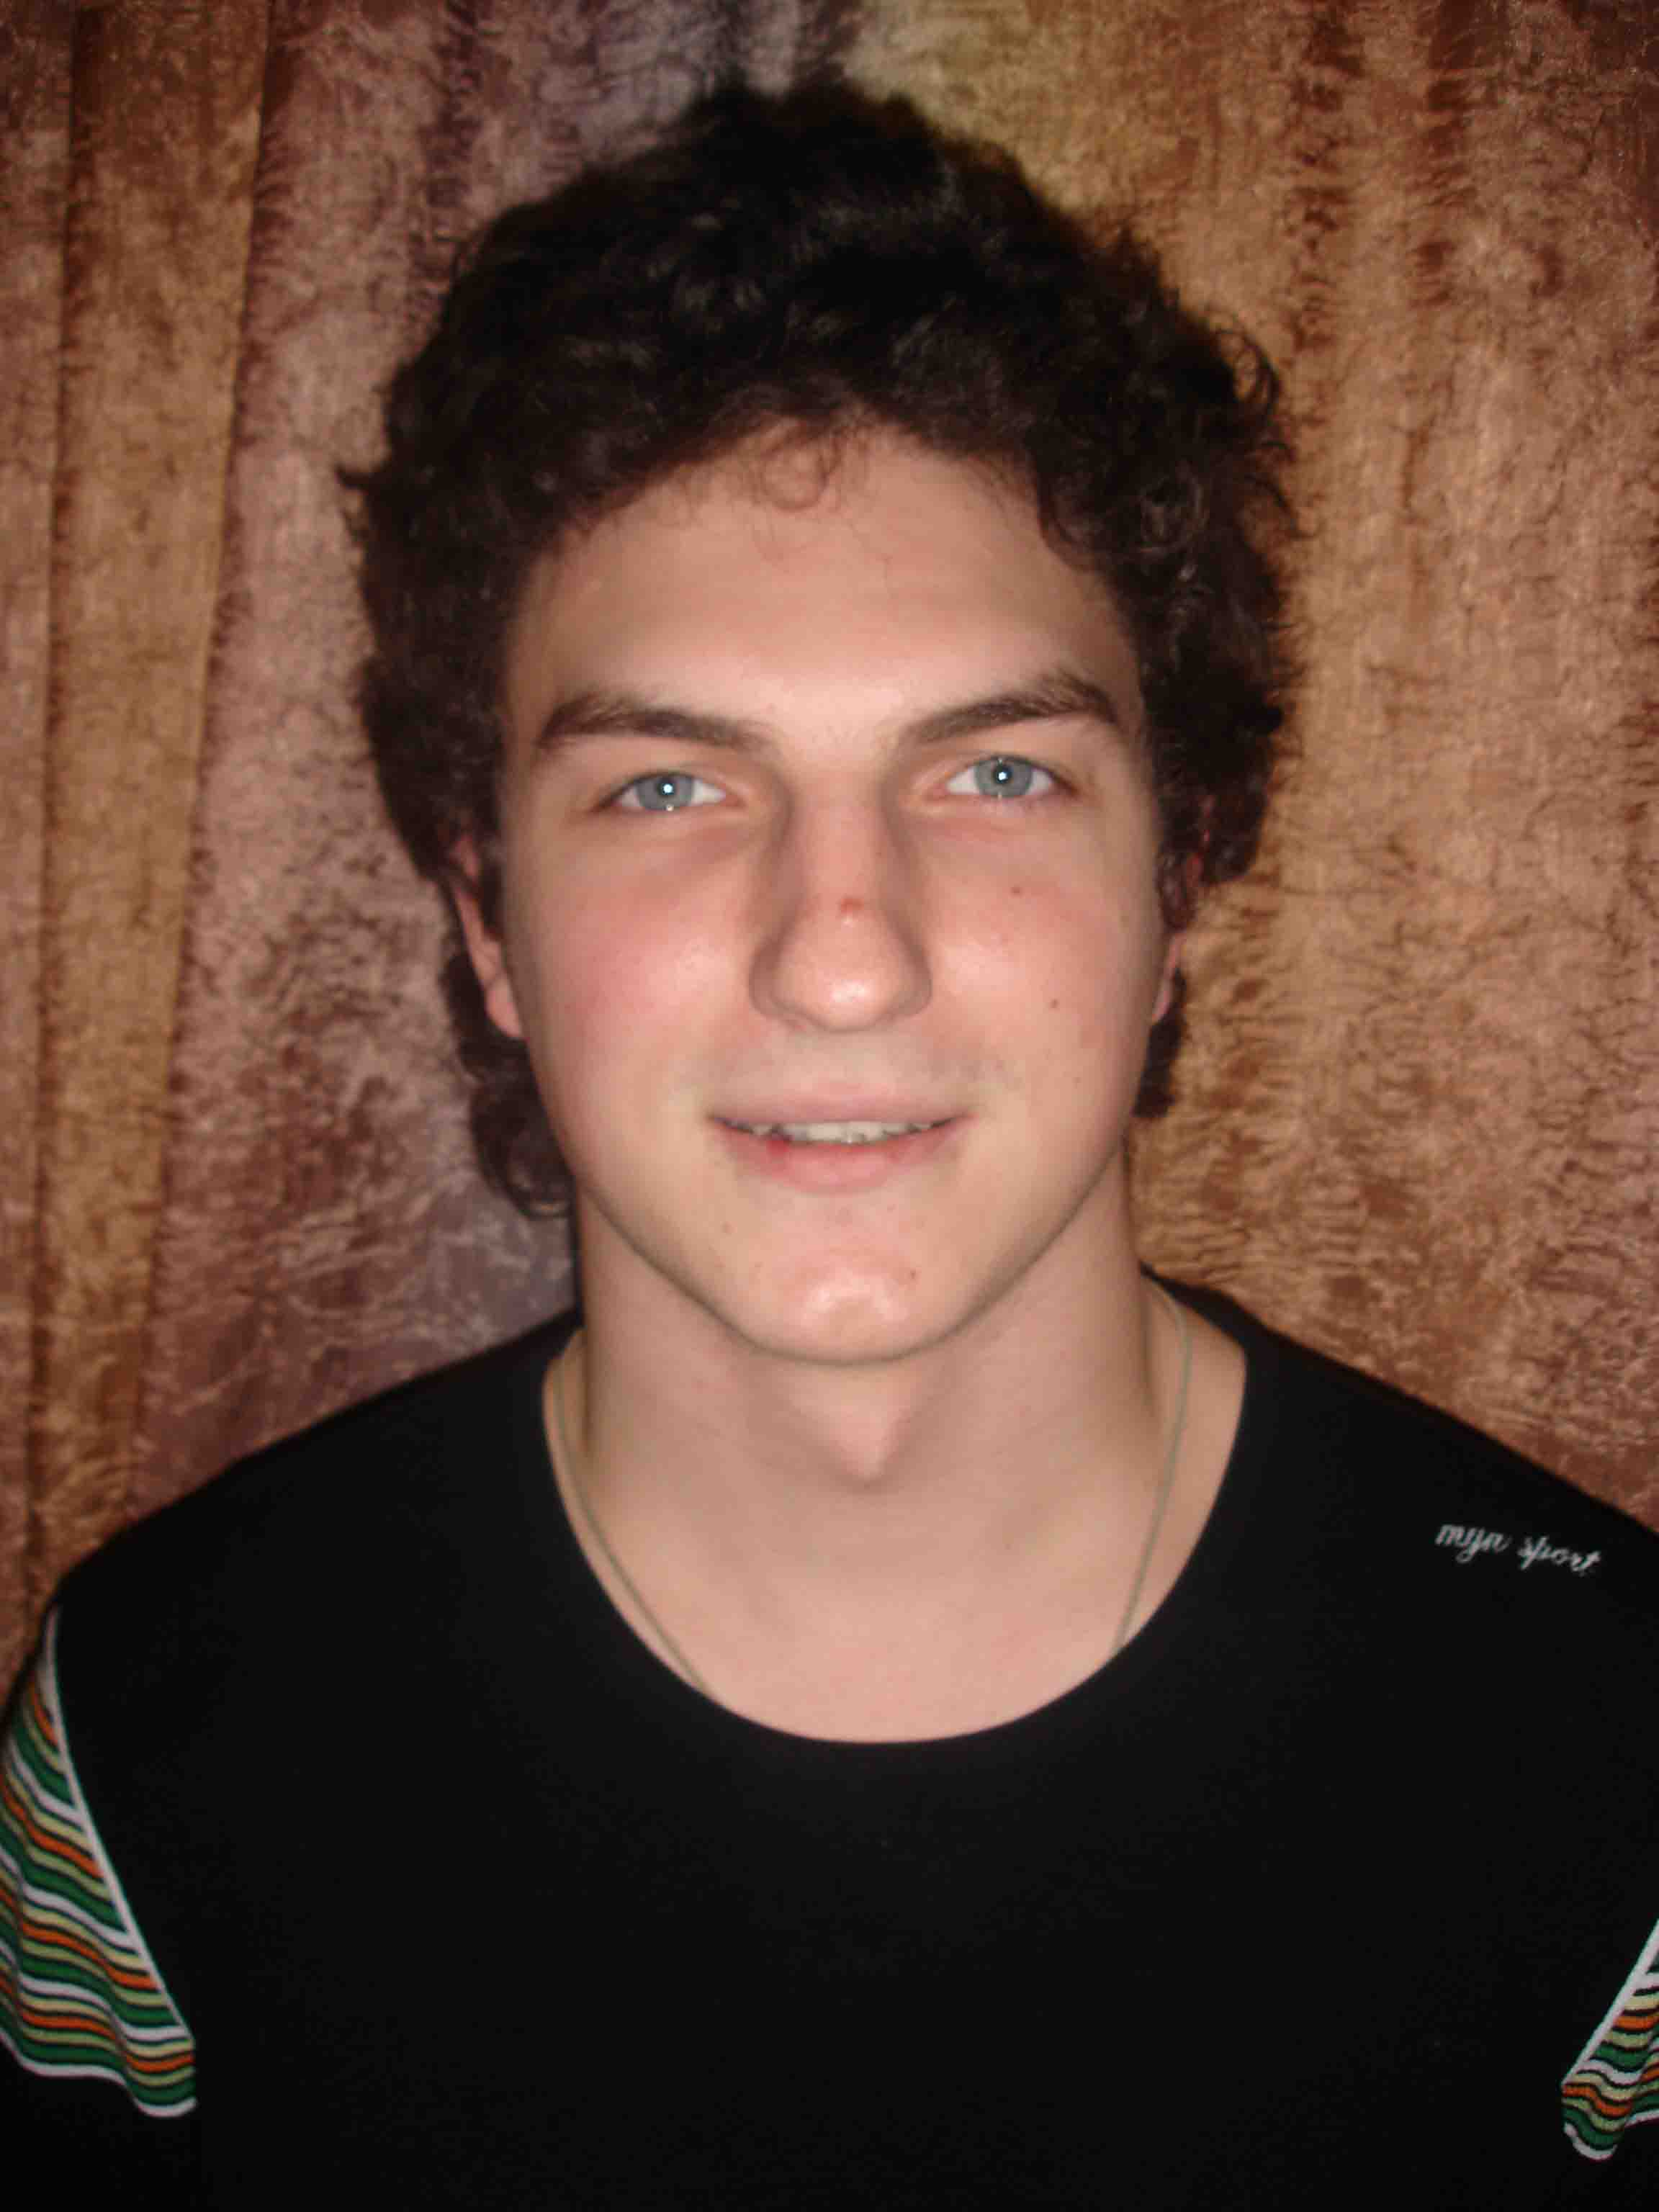

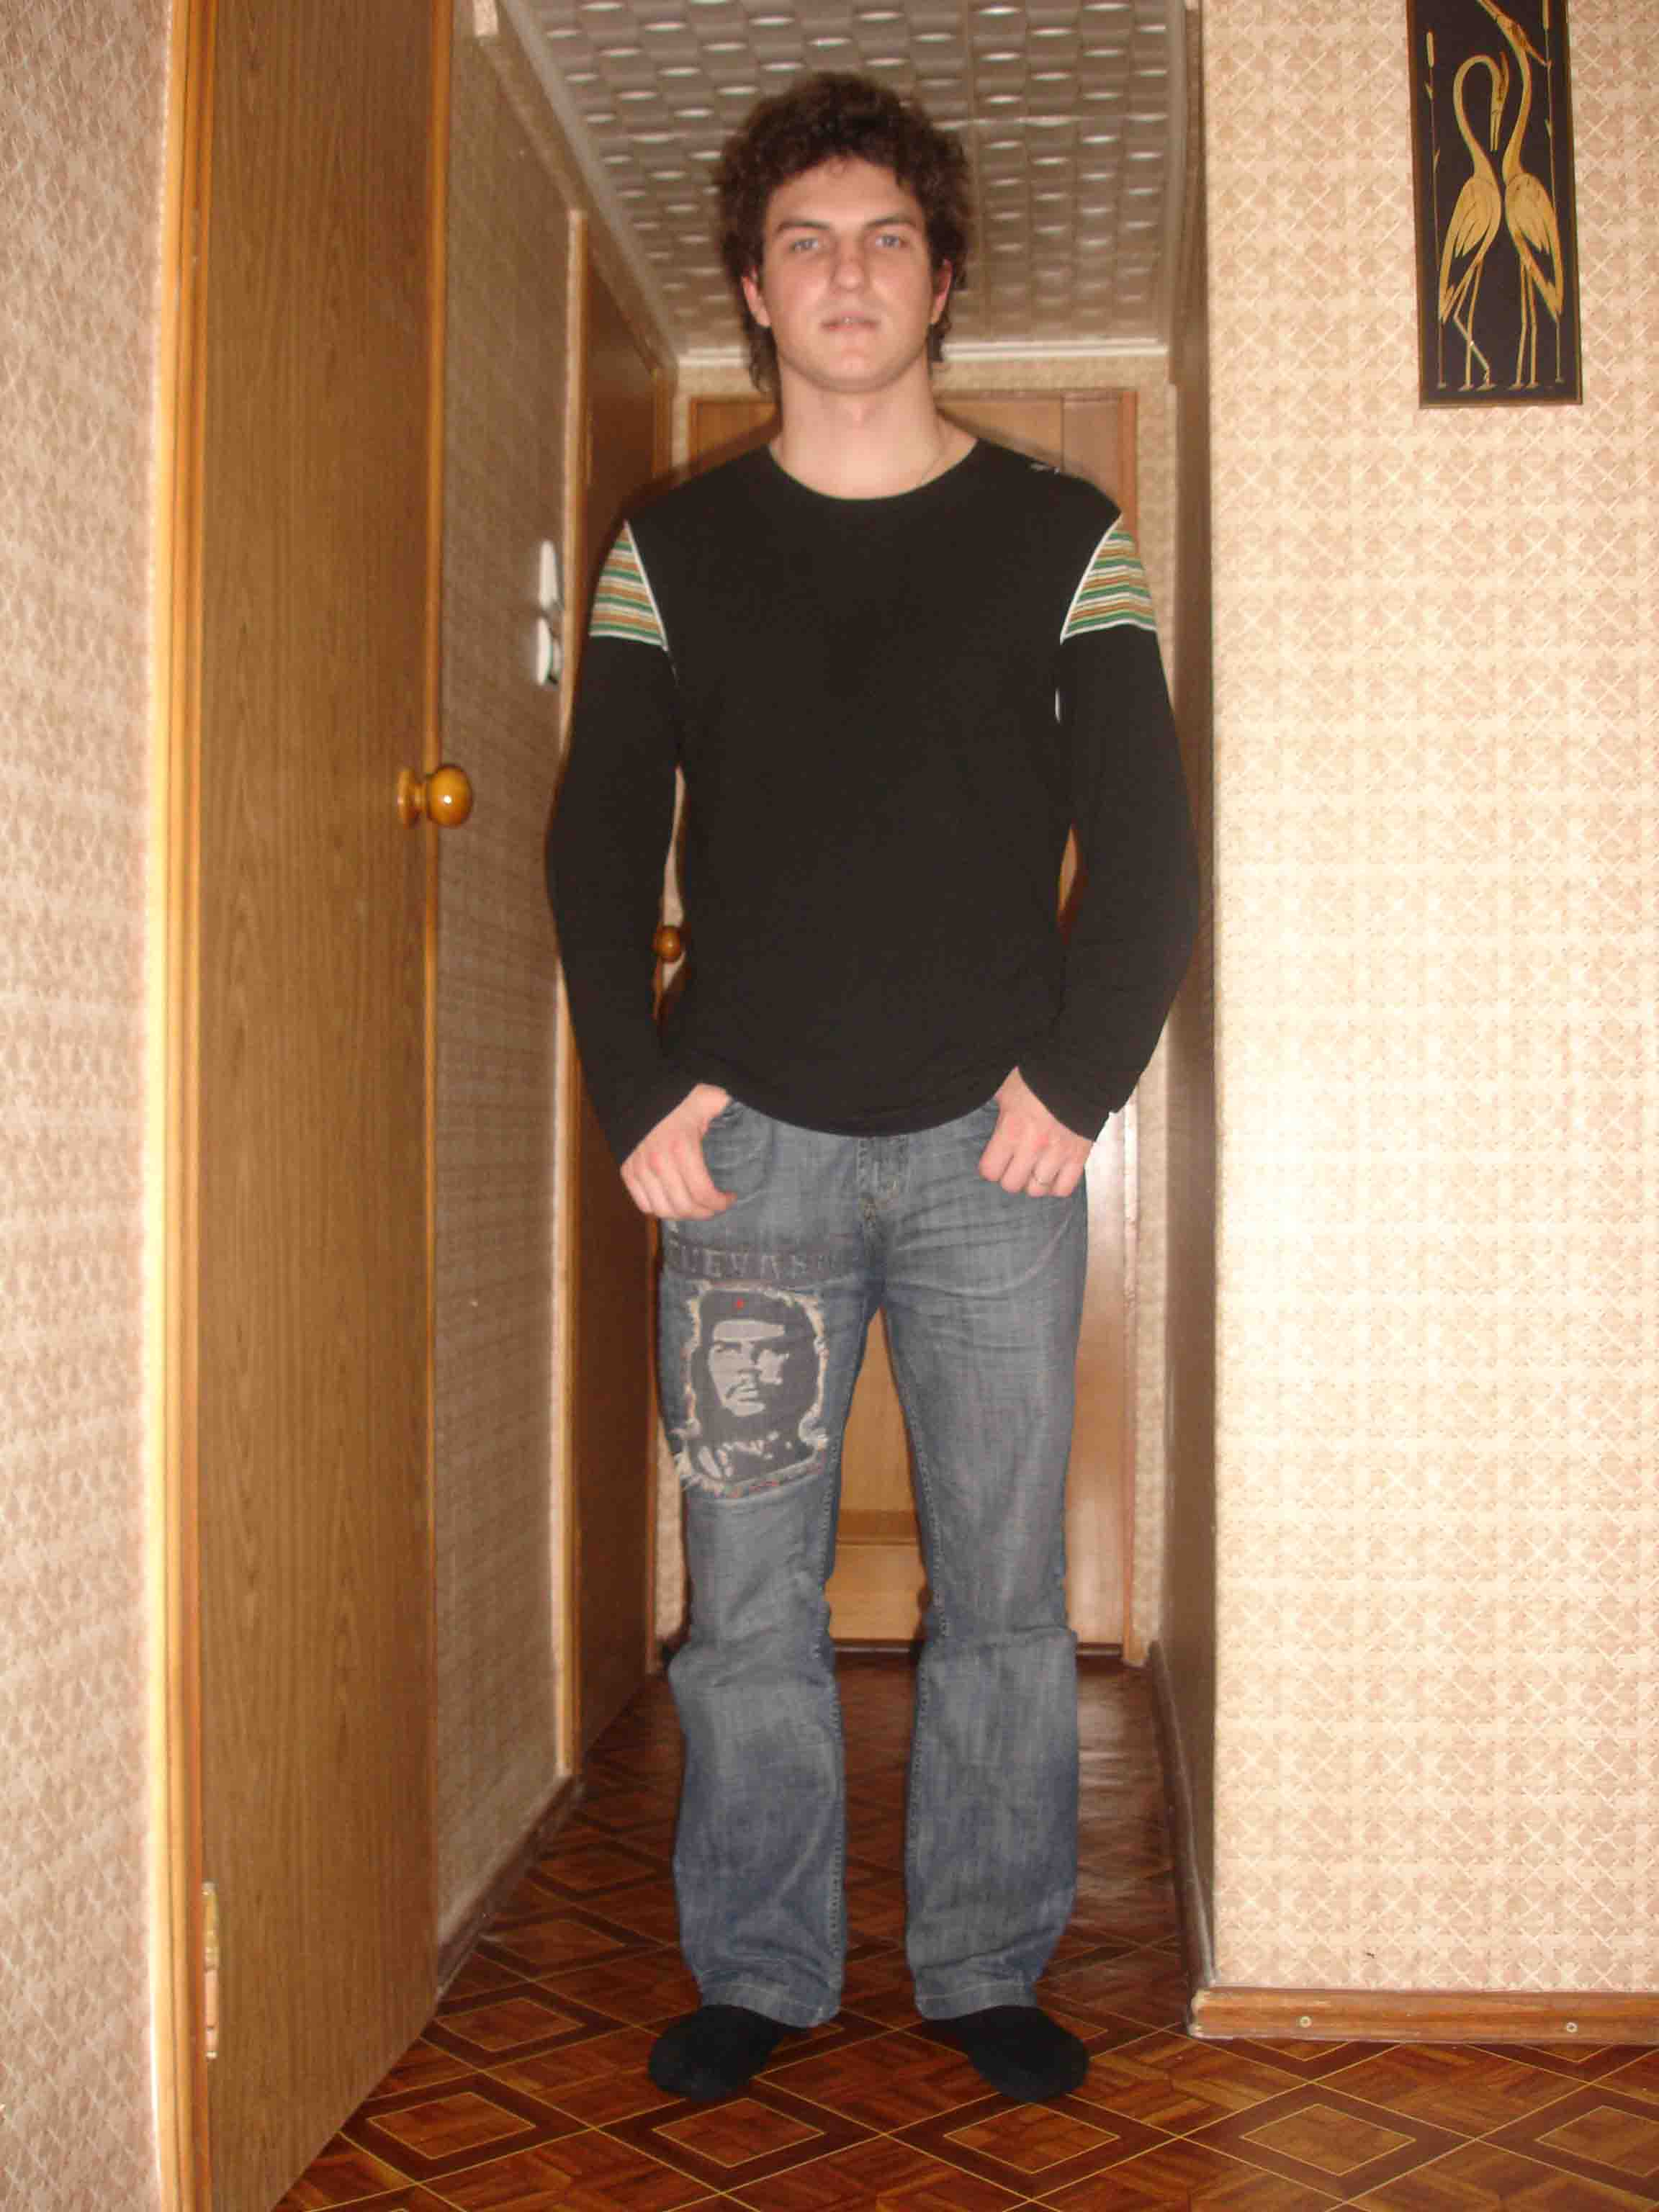

For office use only:

Speak English _4__ Listen English _4__ Interviewer ________XXXXX _____

(1 – beginner, 2 – pre-intermediate, 3 – intermediate, 4 – upper-intermediate, 5 – fluent)

